LESSON PLAN: NATIVE AMERICAN POTTERY
Grade/Audience: 5-8
State Standards:
- Students will understand, select and apply media, techniques and processes. (CT Visual Arts Standards: Content Standard 1: Media)
- Students will understand the visual arts in relation to history and cultures. (CT Visual Arts Standards: Content Standard 4: History and Cultures)

Lesson Objectives:
- Ancient civilizations were always very dependent on their environment for survival.
- The Pequot Indians lived in a village, working as a village to develop their society and culture.

Lesson Objectives for your Students:
- Students will learn the importance of pottery in Pequot culture and Native American villages.
- Students will create their own form of pottery out of clay, adding their own piece of Wampum.

Compelling / Guiding Questions:
- how did the pequots make pottery?
- in what ways is pottery important in the native american culture.

Description of Learning Tasks / Activities:
- Students will view ‘Native American Pottery’ PowerPoint and discuss.
- Students will view primary source documents of images of Native American pottery and discuss.
- Students will complete a drawing handout, “Design a Pinch Pot’ texture, form and decorative element of the Wampum.
- Primary Source documents will be read and discussed.
- Using clay, students will create a pinch pot, reflective of one of their designs. Space will be made for the Wampum piece added after firing. (texture, form)
- Upon firing, students will glaze their pottery for a 2nd firing.
- Decorative elements will be added upon 2nd firing: beads, feathers, Wampum.
- Students will display their pottery in the classroom during a group critique.

Time Needed for Lesson:
4-5 hour classes

Materials, Resources, Technology Needed:
- PowerPoint on ‘Native American Pottery’ https://docs.google.com/presentation/d/1bjcwRfL86Py7bYnFbjzCDJNwnembBVMEqkoplpfsnxg/edit?usp=sharing
- Design A Pinch Pot Handout - https://docs.google.com/document/d/1ENbvIJjglICNnuF0MuT89Z-vK01a9pbyL5PYSGQuXOw/edit?usp=sharing
- Clay, modeling tools, glazes, brushes, water

Primary or Secondary Resources (Works Cited):
(Attached in LP and available online at Google docs)
https://docs.google.com/document/d/1SFwNPn-wLwA7ND6wdkQ7EpM0tYdjEAWZAfItZ1ljn9s/edit?usp=sharing
Native American Jar https://docs.google.com/document/d/1RdIppN0lkdml4HO3JjxLqDRImhMPrItlVW-DKdxg3MI/edit?usp=sharing
https://docs.google.com/document/d/1ElnQTeRU-mds_itMg9vRtdSBxHXJk643ihJMWU03LC8/edit?usp=sharing
https://docs.google.com/document/d/1WQJGT1fOqwqZozuchs9ikTqGYTs4OfxtwlmuxhssOSI/edit?usp=sharing
Pequot Pottery https://docs.google.com/document/d/1-mo0Veoae2ZBXm3NZQJGyOWEJfK6VpvW1mjjT-Gq7es/edit?usp=sharing

Prior Learning, Connections, Student Needs or Interests, Common Misconceptions:
- Native American Studies
- For students to understand that all Native Americans were not the same, and that different tribes and regions had different lifestyles and resources.

Suggested Differentiations:
- Clay can be manipulated by almost all students so little modifications need to be made.
- Textures and patterns can be used with a variety of objects for all levels.

Cross-Disciplinary Connections:
- Social Studies
- Language Arts
- Geography

Formative Assessment processes (including student self-assessment):
- Art Critique Assessment – Students display pottery around room for group discussion.
TAG REVIEW – Post Tag Review Poster on the board.
Post Art around room for review.
Students must use a ‘T’, an ‘A’ or a ‘G’ when they respond to their peers ART.

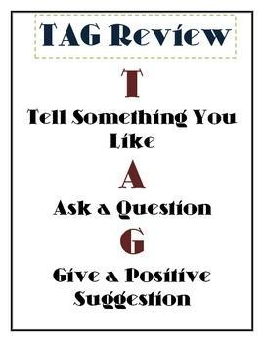

- STUDENT SELF ASSESSMENT
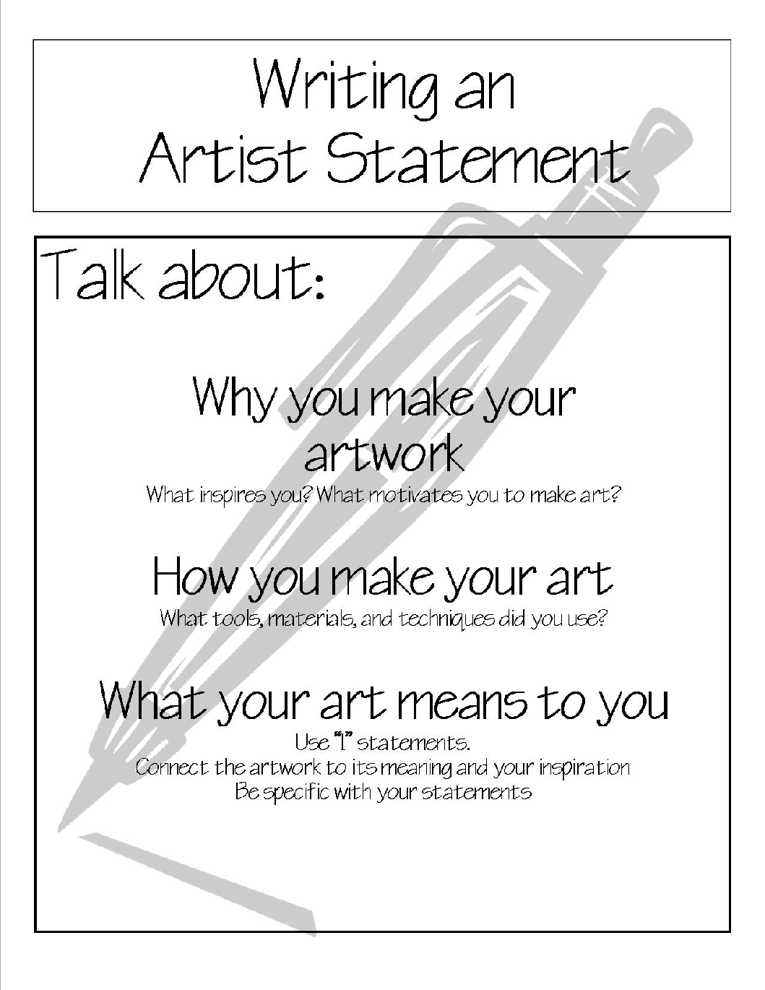

- TEACHER RUBRIC
Pinch Pot | 1 point  Needs Improvement | 2 points  Good Work Habits | 3 points  Excellent
Participation
Craftsmanship
Vocabulary
Name

Score

